**Name : DHANA ABHIRAJ K**

**Roll no : 201CS141**

**Dept : CSE**

-------------------------------------------------------------------------------------------------------------------------------

**TensorFlow**

**- >** Performing high end numerical computation

**Rank Tensor types**

**-> Scalar**

– 0 rank

- magnitude and no direction

e.g – height number

**-> Vector**

– 1 rank

- magnitude and direction

- 1 line

**-> Matrix** - 2d dimensional vector

- 2 rank

- 2 dimensional array

- 2 direction

**-> Tensors** – 3D

Computation graph

**Tensor types**

1. Constants
2. Variables
3. placeholders

**Tensorflow Hands On Documentation**

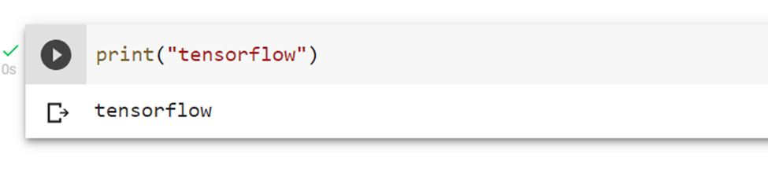

**Disabling the eager execution**

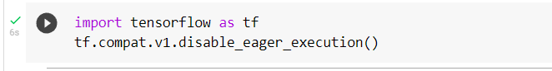

**Starting session**

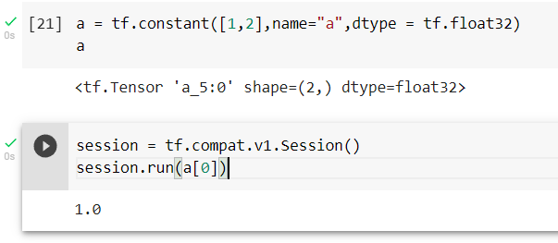

**Scalar - number ,vector - line , matrix - plate , tensor -3D**

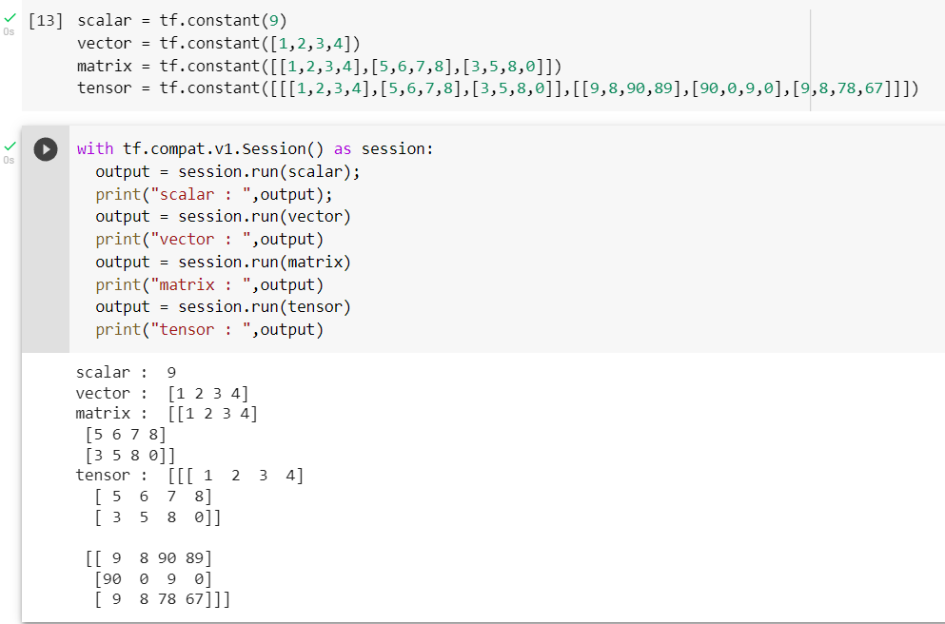

**Printing the tensor variables**

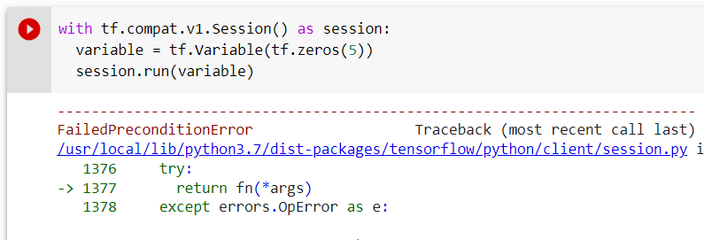

Error is due to the variables not initialized after initializing all the variables in the session the error is rectified.

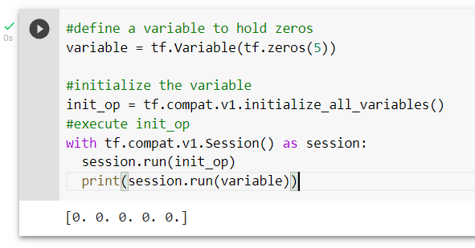

**Changing runtime**

CPU , GPU , TPU - Tensorflow processing Unit

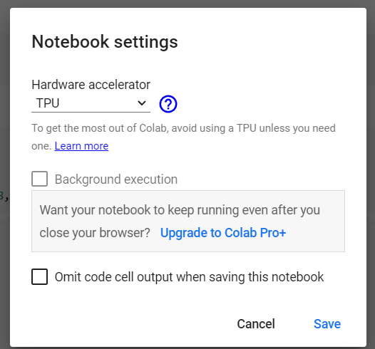

**Convert to tensor**

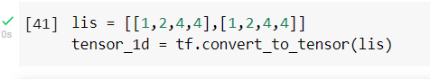

**Parameters - rank,shape,type**

**Rank**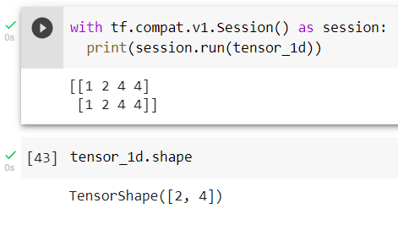

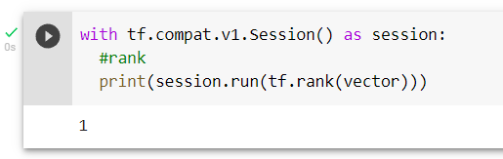

**Normal Multiplication and Matrix Multiplication and determinant**

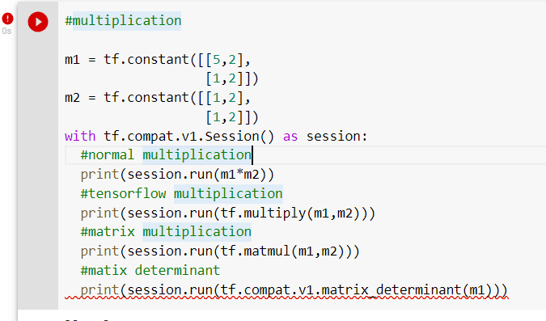



Matrix determinant is not in tensorflow 2.x and it accepts only float, complex

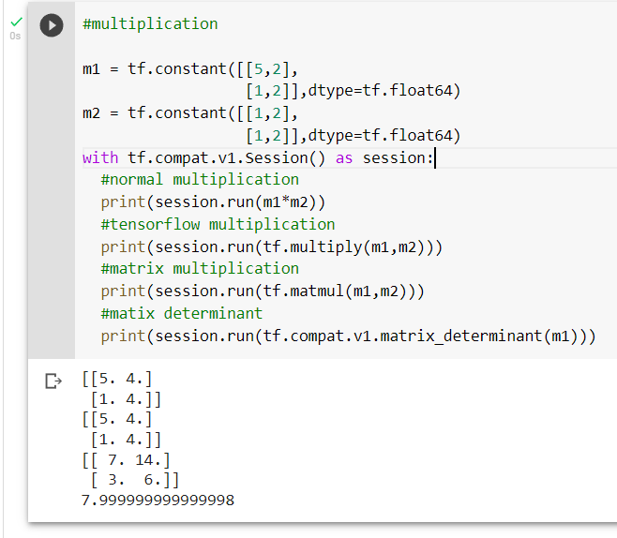

**Day 2**

**range of numbers from 0 to 10 with interval of 0.15**

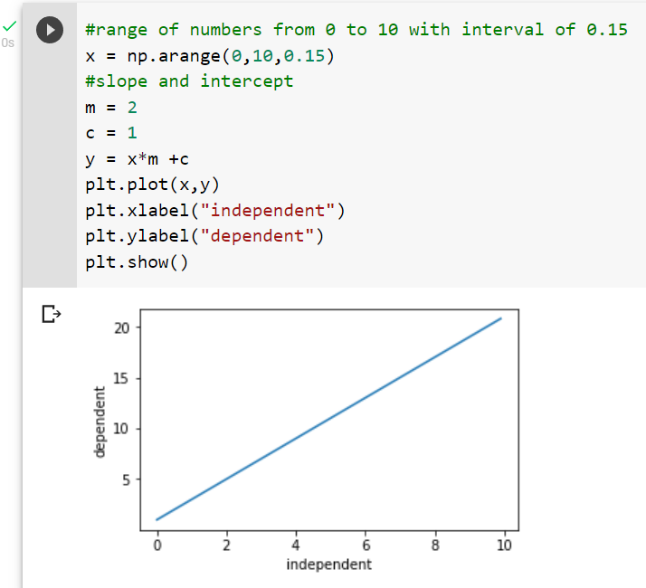

**Standard deviation of 0.5 and center 0 for y**

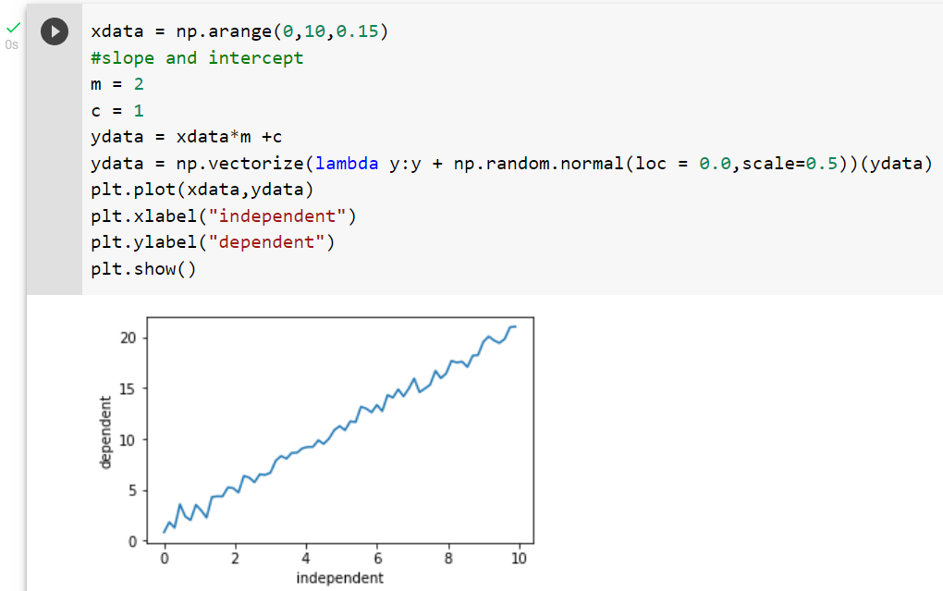

**Random numbers x of 100 values with y**

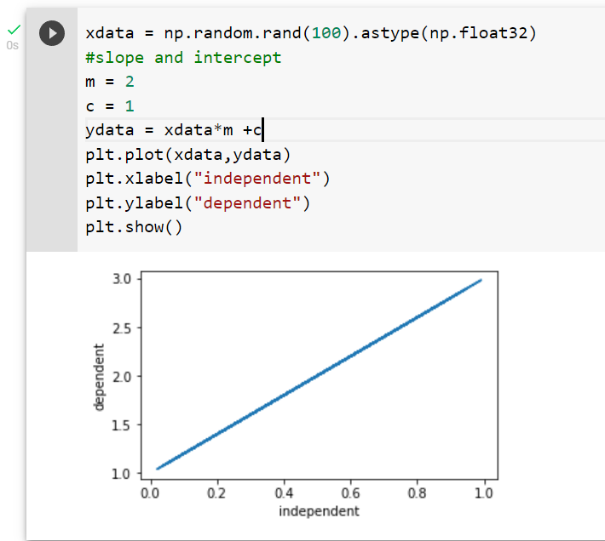

**Random numbers x of 100 values y with center standard deviation**

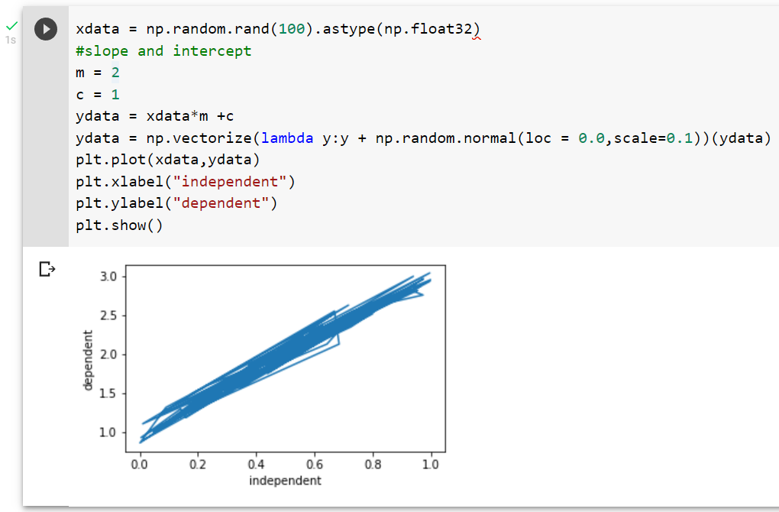

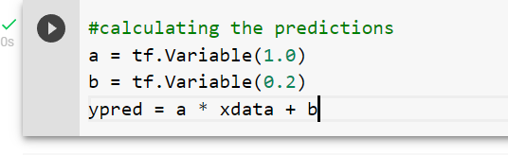

**Finding loss**

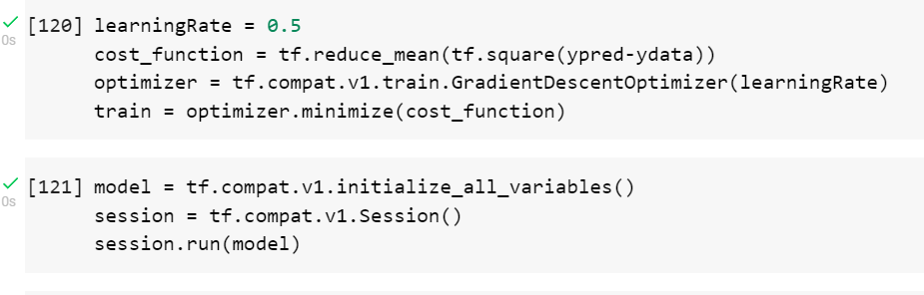

**Building and fitting neural network**

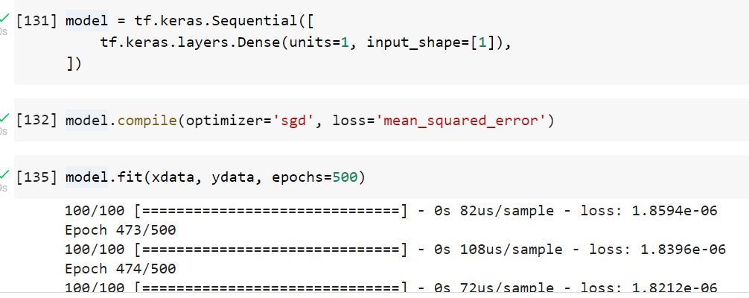

**Predicting y with x**

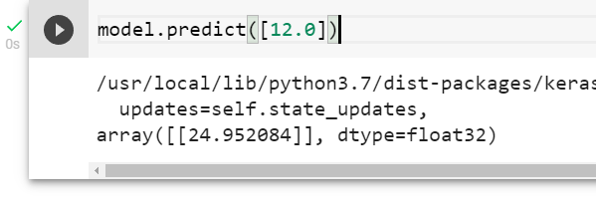

**LINEAR REGRESSION :**

**Car Price prediction - Uploading csv file**

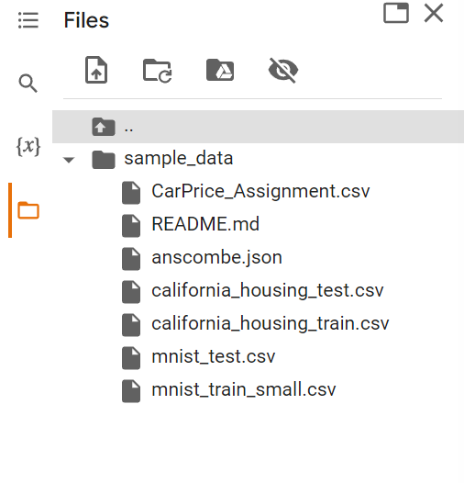

**Reading csv file**

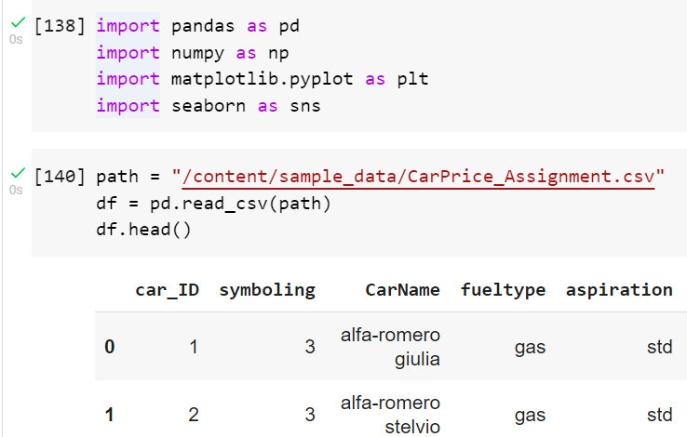

**Finding correlation**

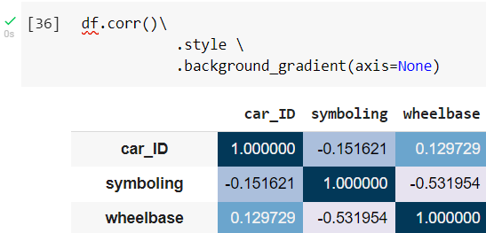

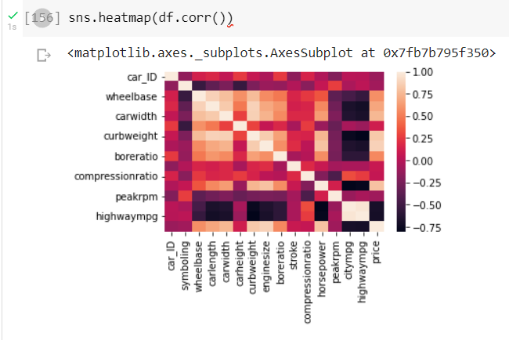

**Selecting the attributes - engine size and price**

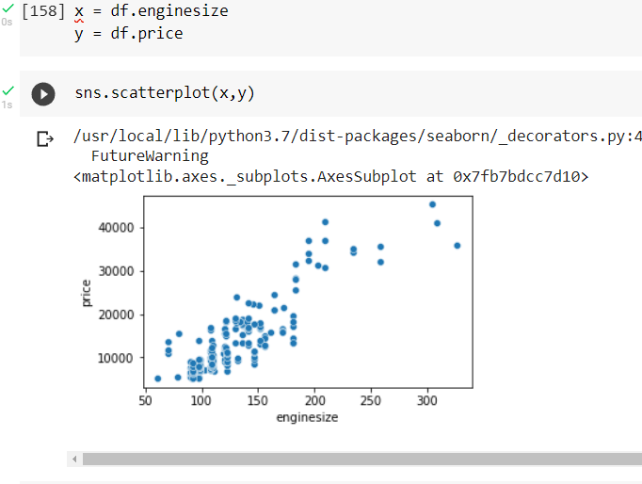

**Splitting into training and testing**

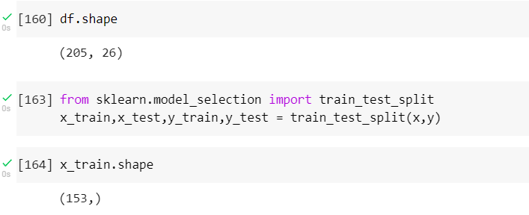

**Linear regression model**

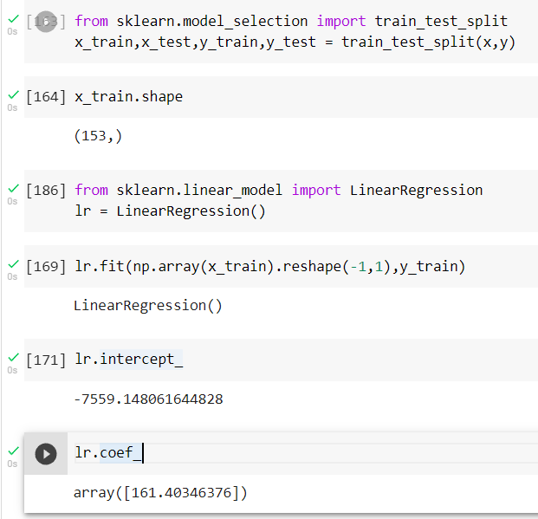

**Drawing a linear line**

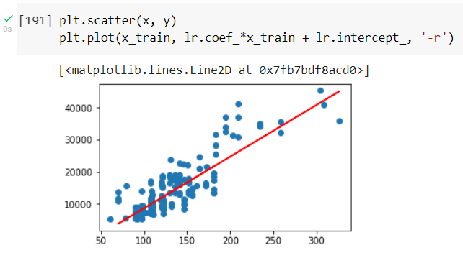

**Prediction and Accuracy**

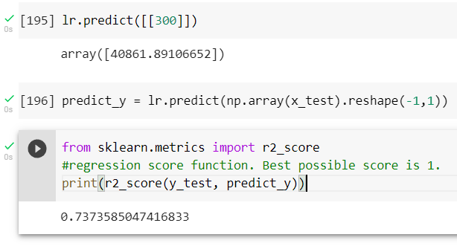

**Logistics Regression**

tf.matmul(X,weights)

tf.add(weighted_X,bias)

tf.nn.sigmoid(weighted_x_with_bias)

**Loading dataset - Iris dataset**

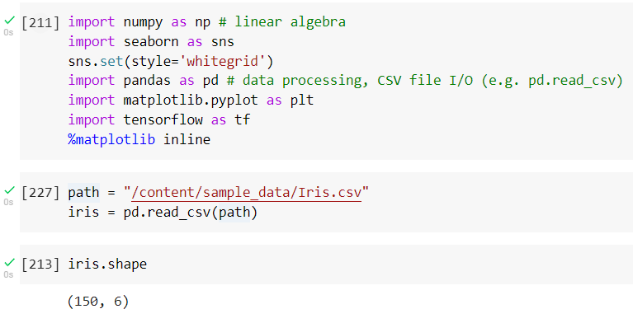

**Head ,tail, unique elements in column**

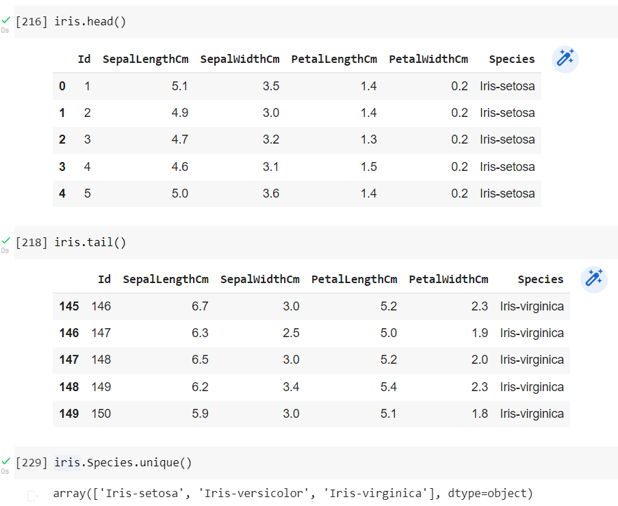



**Replacing and selection two types of flowers for logistic regression**

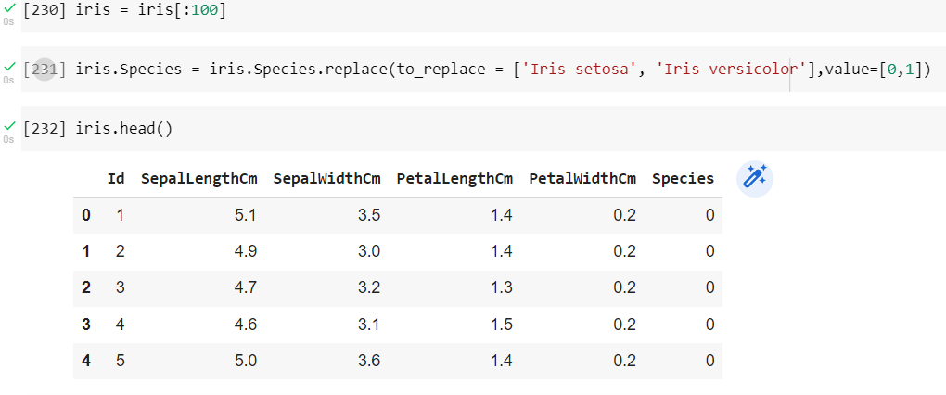

**Visualizing using scatter**

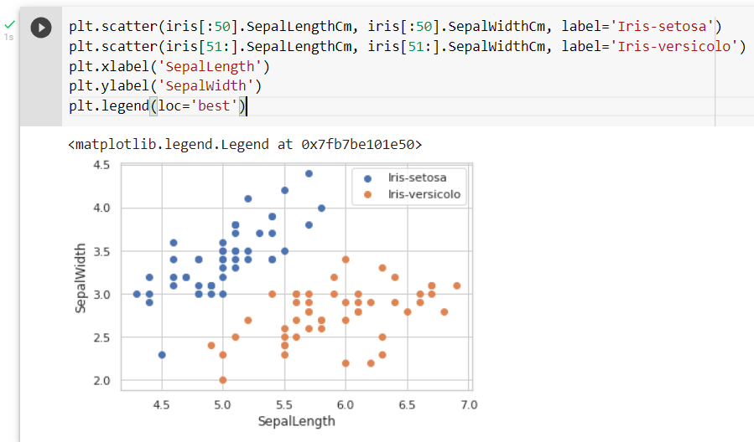

**Set seed**

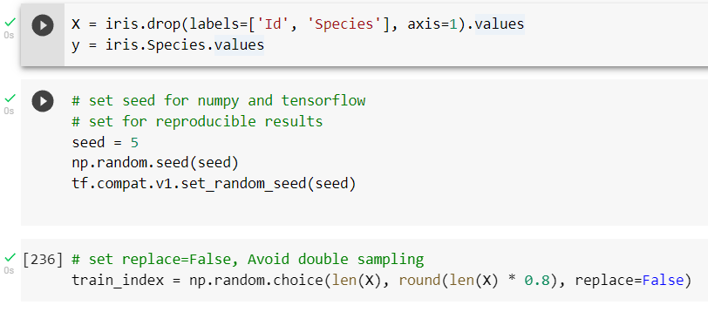

**Normalized function and model framework**

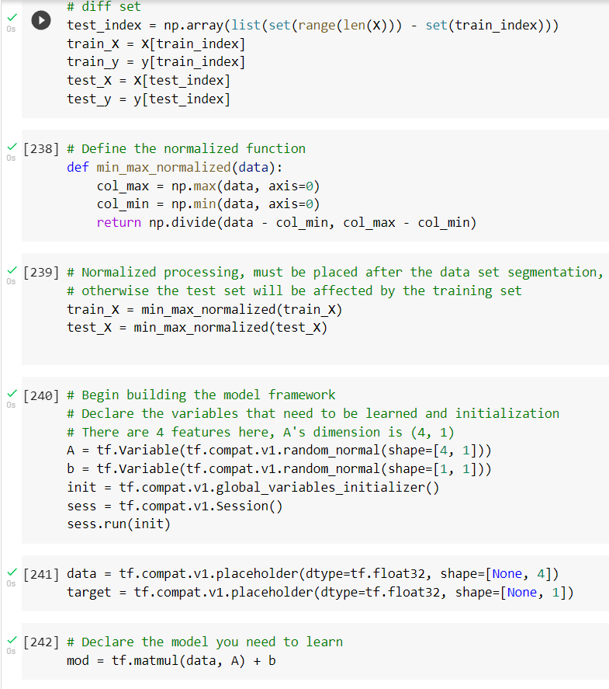



**Loss ,optimizer,accuracy**

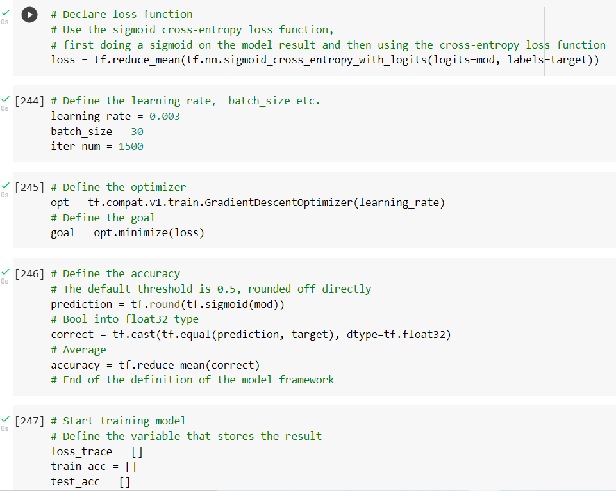

**Training**

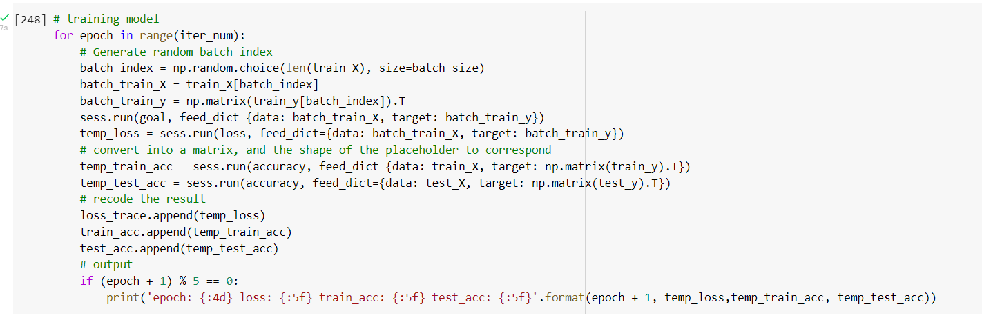

**Visualizing Loss**

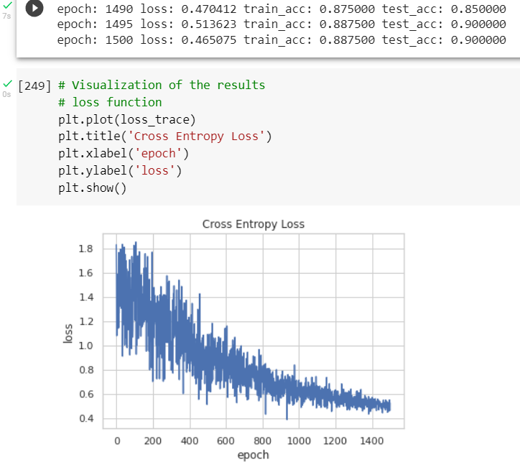

**Epoch vs accuracy**

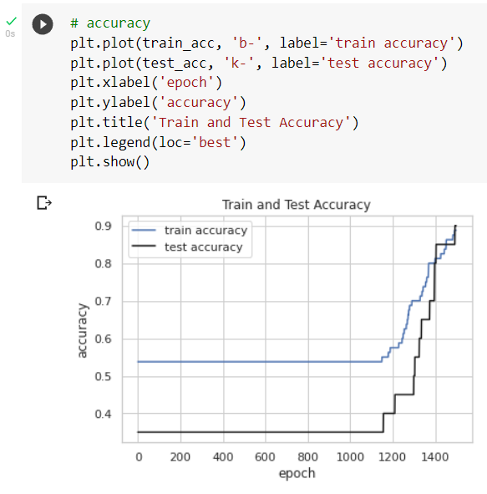

I Learned about tensorflow , linear regression and logistic regression.